**MAVEN PROJECT:**

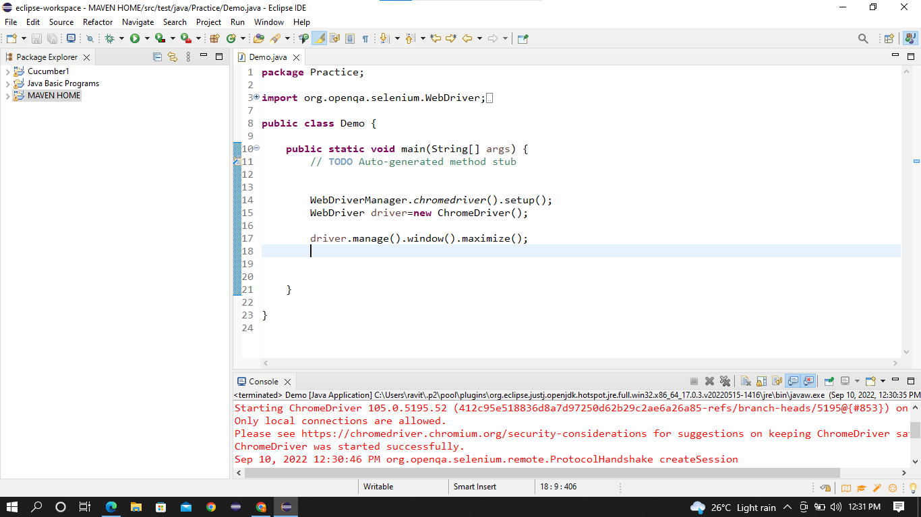

**OUTPUT:**

I have drop the flipkart URL in driver.get() and output attached below.

